2025 VCE Music Contemporary Performance written assessment report
Student responses reproduced in this report have not been corrected for grammar, spelling or factual information.
This report provides sample answers or an indication of what answers may have included. Unless otherwise stated, these are not intended to be exemplary or complete responses.
The statistics in this report may be subject to rounding, resulting in a total of more or less than 100 per cent.

Section A – Listening and interpretation
This section involved listening to three previously unheard works and responding to the ways the performers used the elements of music and compositional devices. A comprehensive understanding of the elements of music, the relevant concepts and compositional devices found in the cross-study specifications (pages 15–19 of the study design) was required. The ability to respond to the interpretative decisions made by performers was also required, together with knowledge of the resultant mood or stylistic characteristics of the work.
To best prepare for the examination, students should begin practising early in the year using the elements, relevant concepts and compositional devices to describe what they hear. Regular practice responding both verbally and in writing to how performers interpret and manipulate these elements in contemporary performance will support this development. As the year progresses, students should also practise completing written responses under time constraints aligned with examination conditions.
Students should read the questions carefully to ensure they are addressing the key ideas raised in each question. Some students highlighted or underlined the key terms in the questions to assist with this, which is strongly encouraged. For example, students should note whether the question requires them to address particular elements, relevant concepts and compositional devices (Question 1a., 1b. and 2b.). In addition, students should read the question carefully to see if they are asked to discuss how the performers create style (Question 1b.) or mood (Question 2) in their response.
Students do not need to repeat the question as an opening statement. Very good responses tended to use subheadings to refer to the specific elements of music. Dot points under each subheading were also useful, enabling students to write concisely, be specific and clearly address the question. Higher-scoring responses were able to link the elements, concepts and compositional devices to the mood or style. Students need to ensure that the link is logical. For example, it is not self-evident that vocals singing legato phrasing creates a nostalgic mood.
The highest-scoring responses demonstrated a sophisticated understanding of the way the elements, relevant concepts and compositional devices were used, and this was clearly linked to specific musical evidence and made use of appropriate contemporary music terminology.
Overall, the students were generally able to highlight the style or mood successfully, but greater attention needed to be given to how the elements of music, relevant concepts and compositional devices contributed to the identified style or mood. Students should become familiar with a range of vocal and instrumental techniques commonly found in contemporary performance and be able to use contemporary music terminology appropriately. This includes elements and concepts such as texture and tone colour with associated terminology specific to contemporary music performance in a range of styles and genres.

Question 1a.
Mark | 0 | 1 | 2 | 3 | 4 | Average
% | 1 | 17 | 40 | 32 | 10 | 2.3
The excerpt was by Indigenous band Mulga Bore Hard Rock, who are from the desert town Akaye (Mulga Bore). ‘Young Men’ (Younga Barla Mapa) is sung in the Anmatjerre language.
This question allowed for a breadth of responses and most students answered it successfully. In answering the question, students could draw on any musical feature to describe the use of repetition and variation within the excerpt.
The highest-scoring responses evidenced a detailed and coherent description of how repetition and variation were used. They also included a variety of highly relevant and detailed examples and utilised highly relevant music terminology and language. Higher-scoring responses were able to make broad and general links between specific examples from the excerpt that could be discerned aurally and the compositional devices of repetition and variation. Mid-scoring responses provided a basic and simplistic description of repetition and variation, along with some relevant examples and generally appropriate use of relevant music terminology and language. Low-scoring responses provided a partial or unclear description of variation and repetition along with very few examples of limited relevance and an attempt to use music terminology and language of limited relevance.
A reasonably common error was writing about either repetition or variation rather than both, as the question required. Reading the question carefully and underlining key words in the question as suggested above may assist students to avoid this error.
This question highlighted the need for students to consistently practise responding to the compositional devices found in the cross-study specifications, and to use music terminology specific to contemporary music performance when responding to music. Students are encouraged to practise this with previously unheard excerpts in a range of styles as well as their own and their peers’ performance pieces in Units 3 and 4.
The following is an example of a high-scoring response. This example has been retyped and the layout replicated but not edited for accuracy.
Repetition electric guitar riff achieved through repeated staccato attach on notes of phrases = energetic
Vocals utilise repeating melody in verse, creating variation through vocalisations such as ‘whoo’ and variation in contour
Drums utilise variation through fills at the ends of phrases and after stops – using semiquaver snare patterns as well as offbeat hits
Vocals use repetition in legato ‘hey’ phrases at end of lines
Use of cymbal crashes creating variation within straight 8th groove
The following are examples of possible relevant points.
Repetition:
- (guitar riff) strumming pattern in rhythm guitar; fundamentally repeated pattern
- snare accents on 2 & 4; drum rock beat
- repeated chord progression
- harmonic structure: chord progression the same and repeated throughout
- melodic pattern repeated: singer opens, band responds, singer closes
- phrasing and melodic contour: phrasing and melodic contour repeated
- form: after 8-bar intro 2-bar lead-in from vocals backed by 8 bars of the band repeated structure
- dynamics: the same shape throughout
- repeated bass line throughout
- repetition in tambourine playing on the 2 and 4 throughout
Variation:
- introduction: rhythm guitar laying down feel using distortion; lead guitar rhythmic triplet variation over the top cleaner sound
- drums: variety of fills – variation on repeated phrases first fill rapid tom run around the kit, second fill played time with hits on 2 and 4
- duration: lead guitar sustains a long note through the first stop-time phrase when vocals enter, second stop-time phrase varies with the hats keeping time under vocals; no pitched instruments until fills
- variation in melody on repeated phrase
- variation from vocals having the melody to guitar taking the melody/lead
- lead guitar riffs into each 4-bar phrase vary in each phrase
- lead guitar riffs in response to voice vary in style of the work
- tone colour variation in lead guitar solo with effects pedal
- guitar solo: melody references, ornamentation, use of bends, Whammy bar and effects pedal wah-wah

Question 1b.
Mark | 0 | 1 | 2 | 3 | 4 | Average
% | 2 | 20 | 34 | 30 | 15 | 2.4
This question required students to explain how tone colour and texture are used to create style.
Most students answered this question successfully, although some responses focused on only one of tone colour or texture, or explained musical character instead of style.
The highest-scoring responses evidenced a detailed and coherent explanation of how tone colour and texture were used to create style and also showed confident use of a variety of highly relevant and detailed examples, as well as competent use of highly relevant music terminology and language. Higher-scoring responses were able to make broad and general links between specific examples from the excerpt that could be discerned aurally and the elements of tone colour and texture and how these created style. Mid-scoring responses provided a basic and simplistic explanation of tone colour and texture to create style, along with some use of relevant examples and generally appropriate use of relevant music terminology and language. Low-scoring responses provided a partial or unclear explanation of how tone colour and texture were used to create style along with very few examples of limited relevance and an attempt to use music terminology and language of limited relevance.
The following is an example of a high-scoring response. This example has been retyped and the layout replicated but not edited for accuracy.

Style: rock
Electric guitar has harsh and distorted TC (TC = tone colour) due to use of effects and recording techniques – use of distortion = typical of rock style
Texture is dense + thick guitar, drums, bass, vocals and backing vocals = typical of rock – many instruments
the drums have a booming and clear TC, this differs from tone colour of electric guitar, creating multi-layered overall tone colour, creating a denser overall texture as TC is not unified = rock, opposing TCs
vocals use nasal and bright TC through use of high pitch uncomfortable male register – also typical of rock style
piece is homophonic – vocals puncture through due to high pitch, in foreground, though, intro has multiple guitar lines – creates energetic, uplifting character typical of rock
guitar in foreground at start and during solo due to high register – use of high range up the neck creates nasal, penetrating TC – guitar comes to foreground. This is typical of rock as a guitar solo is a typical aspect.
The following are examples of possible relevant points.
Style: hard rock; desert rock; blues
Tone colour:
- rhythm guitar: distortion, abrasive, screechy, wailing, generally mid/high pitch supporting this as well as loud dynamics in opening; metallic, clear, with less ‘bite’ in the sound than the lead guitar; generally dry with not a lot of reverb
- lead guitar: use of effect pedal within solo assists in making this line stand out more; using EQ and taking out the bottom end of the sound creating a hard rock style
- bass: clear, dry, crisp, loud
- drums: crisp, clear, some reverb/echo on cymbals, attack on the kit generally centred and clear
- vocals: clear text, with a sense of belt/wail in the sound to cut over the sound of the band. Vocals supported by mic but without reverb. The singers’ tone is nasally, helping to provide cut to the sound.
- overall: band is blended in a clashing, distorted sound, emulating hard-rock genre sounds
Texture:
- Texture is dense; the song begins with rhythm guitar, with power chords and lots of distortion creating a wall of sound effect.
- Lead guitar enters with drums and tambourine adding to the already-dense texture.
- Strong back beat on beats 2 and 4, which is consistent with the style; this is further emphasised with the tambourine on beats 2 and 4.
- Lead guitar is playing a lead melodic line.
- Male vocal enters singing in Aboriginal language (Anmatjerre from Akaye, north of Alice Springs)
- Drums drop out briefly and re-enter with fill.
- There are moments where the guitars stop briefly and there are only vocals and drums; this creates a stop-time feel, adding variety to the texture and moments that are less dense.
- Call and response between the vocals and lead guitar, and vocals and rhythm guitar, with licks at ends of vocal phrases.
- Towards the end of the excerpt is a guitar solo with effects and drums accompaniment, creating a sparser texture with the rhythm guitar absent.
- Drum fills throughout add to the dense texture.
- Bass plays repeated notes on root notes of chords, adding to the overall dense texture.

Question 2a.
Mark | 0 | 1 | 2 | 3 | 4 | Average
% | 2 | 11 | 25 | 37 | 25 | 2.7
This question was generally handled well, with most students identifying two instruments / sound sources for both interpretations. Again, students are reminded to read the question carefully, which asked students to identify instruments / sound sources from the introduction only. Listening to a wide range of contemporary music including electronic music and contemporary music that uses electronic sound production methods to create and manipulate sounds would benefit students to further develop the knowledge required to answer this question.
The following are examples of relevant instruments / sound sources.
Interpretation A:
- synth, bass synth, electronic drums, drum machine, electronic percussion, hand claps, scrapes, samples, electronic keyboard
Interpretation B:
- trumpet, tenor saxophone, baritone saxophone, trombone, horn section

Question 2b.
Mark | 0 | 1 | 2 | 3 | 4 | 5 | 6 | 7 | 8 | Average
% | 1 | 4 | 12 | 16 | 22 | 19 | 15 | 8 | 4 | 4.3
This question required students to discuss the ways in which the two interpretations created different moods through the use of articulation and rhythm.
Responses were presented in a range of formats and various approaches were effective. Some students used bullet points and subheadings to list points that were evident in each interpretation. Others used a two-column format, aligning the specific features of each interpretation.
To best prepare for this kind of question, students need to develop a vocabulary of specific terminology for a range of contemporary music performance styles associated with each of the elements of music, relevant concepts and compositional devices. Students are encouraged to develop a list of mood and character words that are relevant to contemporary music, such as upbeat, nostalgic, motivating, energetic, playful, anthemic, frantic, excited, extroverted, uplifting, intense, driven, insistent, dream-like and uplifting.
The high-scoring responses were insightful and sophisticated and answered all aspects of the question. Discussion of how articulation and rhythm were used in each interpretation to create two distinct moods was highly appropriate, accurate and clearly expressed. Highly relevant examples were judiciously selected with precise and effective use of relevant music terminology and language. Mid-scoring responses were mostly detailed and relevant. Knowledge of how articulation and rhythm were used in each interpretation to create two distinct moods was appropriate. Consistent use of examples/evidence from the excerpt was evident and there was some use of appropriate music terminology and language. Lower-scoring responses were competent yet conventional and addressed some aspects of the question. Knowledge of how articulation and rhythm had been used was limited in specificity and detail. There was little use of relevant examples/evidence and what was there sometimes lacked accuracy. There was some use of music terminology and language that was not always relevant and/or lacked accuracy. The lowest-scoring responses were basic and addressed part of the question that was more of a broad outline. Limited knowledge of how articulation and rhythm had been used in each interpretation was evident. There was minimal use of relevant and accurate examples/evidence from the excerpt and minimal use of appropriate music terminology and language.
The following is an example of a higher-scoring response. This example has been retyped and the layout replicated but not edited for accuracy.
These two versions of Such Great Heights are very different. Interpretation A has a dream-like, playful and uplifting mood, whereas Interpretation B is much more energetic, driven, insistent and excited.
A | B
Rhythm  the piece has a fast tempo, with a strong crotchet beat and straight 8ths feel  the vocals are very strict in time in both the verses and choruses of the excerpt  the drum machine maintains a consistent beat throughout the excerpt, with the occasional syncopated clap  Articulation  the arpeggiator in the beginning has a very strong attack  the drum machine also has a very strong attack and quick release  the vocal phrase have lots connection and use of legato  the electric piano-like instrumentation uses sustained arpeggiated chords, creating a more atmospheric like quality | Rhythm  the piece opens with a very busy and dense rhythmic texture at a similar tempo using lots of syncopation and polyrhythms  the acoustic drums have great progression of drum-beat, playing a classic off-beat feel, then progressing to a busier drum-beat with a driven and clear straight 8ths feel  Articulation  the piece opens with staccato high pitched trumpets and long-held baritone saxophone – great variation in articulation  the vocal phrases use legato to connected phrases, and quickly cuts off the end of the phrases  the hi-hat towards the end of the excerpt is played slightly open, creating a greater sense of energy
The following are examples of possible relevant points.
Mood:
- Interpretation A: ethereal, atmospheric, relaxed
- Interpretation B: energetic, frantic, driven
Articulation:
- Interpretation A: sustained bass synth, strong accents drum machine on beats 2 and 4, clear attack and sustain on raindrop-like synth, vocals have clear articulation and sustain words at ends of phrases
- Interpretation B: brass/horn section in the introduction play rapid, tongued quavers, creating an energetic and frenetic mood; syncopated tongued notes in the trombone supports the energetic mood; vocals sing smooth, slurred phrases with accented notes, adding contrast; drumkit accents on beats 2 and 4; horn section is reintroduced in the chorus and contrasts with the introduction, adding bends, growls and scoops; trumpets sit on top, playing long notes and adding glisses and bends

Rhythm:
- Interpretation A: consistent straight 8ths feel in opening synth pattern; syncopated, off-beat drum machine; syncopated hand claps and scrapes; strong accent drum machine on beats 2 and 4; fast tempo, consistent throughout; vocals generally on the beat with accents on beat 1; 4/4 time signature
- Interpretation B: sudden change in tempo when vocals, drums, bass enter, much faster than interpretation A; trumpet and tenor sax, complex interplay between on-beat and syncopated quavers create complex rhythmic feel; intro: sustained baritone saxophone part enters, accents on beat 1; drums enter with vocals, off-beat accents; 4/4 time signature

Section B – Music language
For this section, many students used a sharp pencil(s), which is strongly advised. Students should take great care when completing the music documentation using the staff or alternative documentation options and ensure there is no ambiguity in the pitch or rhythm when writing notes on the staff or completing the graphic notation. When undertaking transcription questions using staff notation, students are advised to complete their rough work on the blank manuscript paper provided and then transfer a neat, legible copy of their final response to the space provided for the answer. Students should provide only one response for transcription questions where they are asked to document the missing notes by drawing on the staff or writing letter names or completing the rhythm grid.
Where possible, while completing Year 12 students should have access to appropriate aural training software and a Digital Audio Workstation (DAW), to sequence rhythms, chords and chord progressions for aural practice. Students are encouraged to regularly practise all the required skills and knowledge through singing, playing and documenting all diatonic intervals, scales and modes, short melodies, triads, chords and chord progressions in a ‘little and often’ and ‘sound before sign’ approach, both in context and in isolation.

Question 3a.
Mark | 0 | 1 | 2 | Average
% | 66 | 20 | 13 | 0.5
- The first interval was a major sixth.
- The second interval was a minor third.
To obtain the mark, both quality and quantity needed to be correct.
Many students did not score well on this question. Students are reminded to practise hearing and identifying intervals that are presented melodically and harmonically, ascending and descending, and in context as well as in isolation.
Students must avoid using ‘M’ or ‘m’ to indicate intervals, as this is unclear; they should instead write ‘minor’ or ‘major’. If the interval was not clearly identified, it was deemed incorrect.

Question 3b.
Mark | 0 | 1 | 2 | Average
% | 18 | 24 | 59 | 1.4
1.
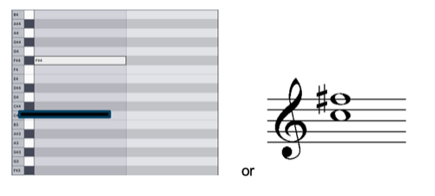
2.
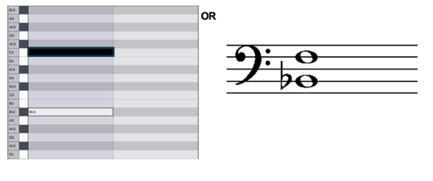
The majority of students correctly wrote/drew the intervals using the graphic notation or five-line staff notation.

Question 4a.
Mark | 0 | 1 | 2 | Average
% | 12 | 36 | 53 | 1.4
- minor pentatonic
- major
Most students correctly identified the scales or modes.

Question 4b.
Mark | 0 | 1 | 2 | Average
% | 19 | 53 | 29 | 1.1
- blues
- mixolydian
Most students correctly identified the scales or modes.

Question 5a.
Mark | 0 | 1 | 2 | 3 | 4 | 5 | 6 | 7 | 8 | Average
% | 22 | 32 | 16 | 10 | 6 | 2 | 5 | 3 | 5 | 2.1

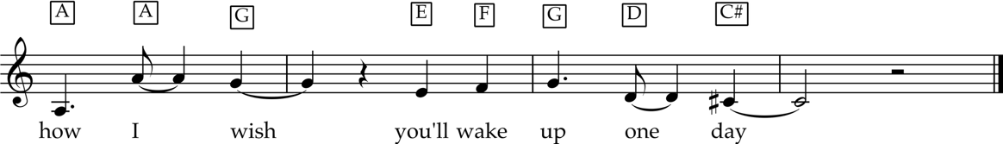

Many students did not score well on this question. This question was an example of a melodic dictation in context using the excerpt performed by Laufey. Both the original audio and the documentation were transposed down a semitone for the examination from Db to C. The final missing pitch, C#, was the 3rd of the A7 chord in the underlying harmony. Db was also accepted.
Students are encouraged to use the information given wherever possible; for example, the first pitch of the missing documentation was the same as the pitch immediately preceding it in the previous given bar. This was followed by an octave leap; identifying the interval would have assisted here.
Students were asked to document the missing notes by either drawing the notes on the stave or writing letter names in the empty boxes. Students are reminded to read the question carefully – some students documented the pitches on the stave and wrote letter names; in this case, only the first response was assessed, which was the letter names in boxes. Students who use the staff are strongly reminded to use a pencil and write neatly and carefully, clearly indicating which notes are on a line or in a space. Some students did not clearly indicate whether notes were on a line or in a space and when this was unclear, this was deemed incorrect.
In contemporary music, listening and copying recordings through playing and singing is a common way of learning, and this can be extended to include documenting short melodic ideas. This approach is to be encouraged to develop the aural skills required for this question type.

Question 5b.
Mark | 0 | 1 | Average
% | 86 | 15 | 0.1
The rhythmic feel was straight eights.
Many students did not score well on this question. Students are reminded to practise identifying (and recreating) a range of rhythmic feels found in contemporary performance; some examples are given in the study design on pages 44 and 49. Activities such as listening and creating a playlist of examples, and playing, creating and improvising would assist with developing this knowledge.

Question 6
Mark | 0 | 1 | 2 | 3 | 4 | Average
% | 26 | 30 | 24 | 12 | 8 | 1.5
- major seventh
- minor
- suspended fourth
- half diminished seventh
Responses generally showed a developing command of triads/chords.
Learning by listening and copying recordings is another effective approach common in contemporary music that is also recommended for developing aural skills and the ability to hear chords/triads in context, vertically (harmonically) as well as horizontally (melodically).

Question 7
Mark | 0 | 1 | 2 | 3 | Average
% | 15 | 32 | 24 | 29 | 1.7

Bar | 2. | 5. | 6.
Chord | IV | ii | V
Most students handled this question well. Students are reminded to practise identifying the common chord progressions listed in the study design on pages 44 and 49 and to identify missing chords within these progressions. There are only a limited number of chord progressions given, which assists students in identifying the missing chords.
Regular practice recognising chords as part of a chord progression is recommended. In contemporary music, listening and copying recordings is a common learning approach that can be used to practise identifying chords and chord progressions. These approaches are encouraged to develop the aural skills required for this type of question.

Question 8
Mark | 0 | 1 | 2 | 3 | 4 | Average
% | 10 | 15 | 16 | 27 | 32 | 2.6
- The first triad/chord was E G B.
- The second triad/chord was Bb D F A.
- The third triad/chord was A E.
- The fourth triad/chord was F# A C E.
This question was generally handled well. Students were required to write the letter names of the chords. A small number of students wrote the accidental before the chord and this was deemed incorrect; students should write the accidental after the letter name following the example given in the question. Note that enharmonic equivalents such as A# instead of Bb are not correct when writing chords, and such responses were deemed incorrect.

Question 9
Mark | 0 | 1 | 2 | 3 | 4 | Average
% | 14 | 25 | 27 | 15 | 19 | 2
The fragments were heard in the following order: B D F C.
This question was generally handled well, with most students identifying at least two of the fragments in the correct order. Students are reminded that memorising the missing rhythm when it is played would assist, as students can ‘replay’ the rhythm in their heads during the silent working time. As this was a multiple-choice question, students may have also found it useful to focus on one missing rhythmic pattern fragment for each playing.

Question 10
Mark | 0 | 1 | 2 | 3 | 4 | 5 | 6 | 7 | 8 | Average
% | 4 | 5 | 14 | 15 | 15 | 12 | 12 | 7 | 16 | 4.5
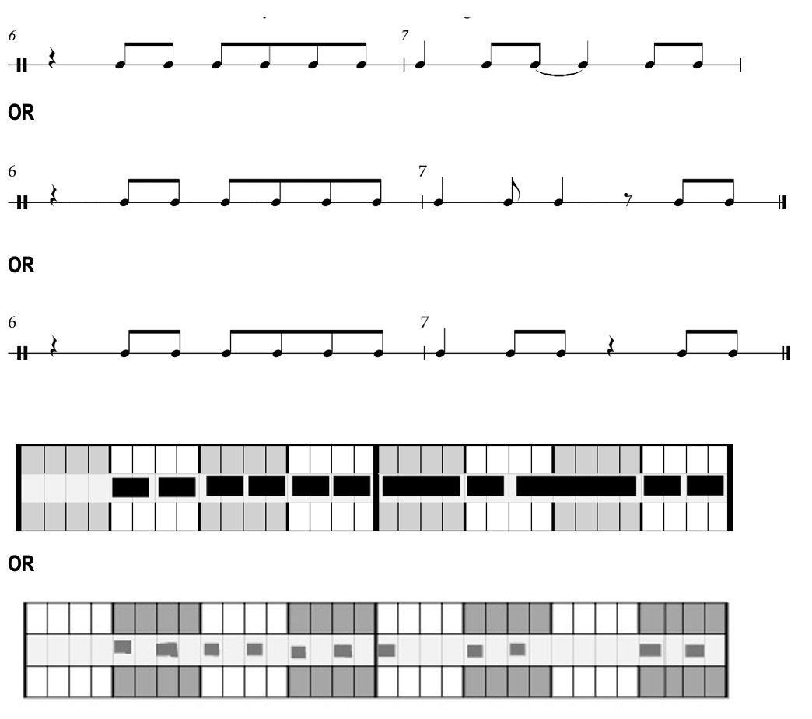
Students were able to choose between two options to respond to this question. Many students chose to respond using the rhythm grid, a method of documentation that is an option in the study design.
Students were asked to transcribe the missing notes by either drawing the notes on the staff or in the rhythm grid. Students are reminded to read the question carefully; some students transcribed the pitches on the staff and drew in the rhythm grid. In this case, only the first response was assessed, which was the staff notation.
Students who choose to respond using the 5-line staff notation are reminded to check carefully that there are no notation errors related to the number of beats in the bar. Students should proofread their response, ensuring that each bar has the correct number of beats; in this case, four beats per bar.
Students are reminded to write neatly and carefully and use a sharp pencil for this question. Some students who responded using the rhythm grid did not clearly indicate whether the first note in bar 7 began on beat 1 or was held across from the previous bar. When this was unclear, this was deemed incorrect.
To prepare for the examination, students should practise a range of forms of documentation as appropriate to contemporary music performance to gain fluency and confidence with a variety of documentation approaches before responding to these types of questions under the conditions and time pressures of the examination.
In contemporary music, listening and copying recordings is a common way of learning; this can be extended to include documenting short rhythmic ideas. This approach would also develop the aural skills required for this question type.

